

|  |  |
| --- | --- |
| **Modelo** | MEC-D3/65B |

|  |  |  |  |  |  |  |  |  |  |  |
| --- | --- | --- | --- | --- | --- | --- | --- | --- | --- | --- |
| MULTIPLICADOR  Revoluciones/ Relación | MODELO | l/min | 800 | 900 | 1000 | 1100 | 1200 | 1300 | 1400 | 1600 |
| m3/hora | 48 | 54 | 60 | 66 | 72 | 78 | 84 | 96 |
| l/seg | 13.3 | 15 | 16.7 | 18.3 | 20 | 21.7 | 23.3 | 26.7 |
| 460/1:7.42  500/1:6.77  540/1:6.28 | MEC - D 3/65B | **H** | **112** | **111** | **110** | **109** | **108** | **106** | **105** | **101** |
| P | 35 | 37 | 39 | 41 | 43.5 | 45.5 | 47.5 | 51 |

H = Altura de impulsión manométrica total en m.

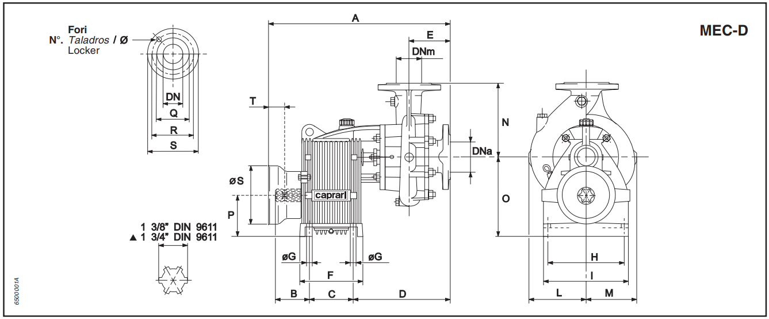P = Potencia absorbida en HP.

|  |  |  |  |  |  |  |  |  |  |  |  |  |  |  |  |  |  |  |  |
| --- | --- | --- | --- | --- | --- | --- | --- | --- | --- | --- | --- | --- | --- | --- | --- | --- | --- | --- | --- |
| **MODELO** | DNa | DNm | A | B | C | D | E | F | G | H | I | L | M | N | O | P | S | T | PESO |
| MEC-D3/65B | 80 | 65 | 603 | 100 | 135 | 280 | 119 | 180 | 15 | 235 | 260 | 188 | 168 | 275 | 244 | 125 | 240 | 126 | 74 |

|  |  |
| --- | --- |
| **BRIDAS** | |
| Ø Boca | 65 |
| Q | 122 |
| R | 145 |
| S | 185 |
| N° Taladro | 4 |
| Ø Taladro | 18 |

|  |  |
| --- | --- |
| **BRIDAS** | |
| Ø Boca | 80 |
| Q | 130 |
| R | 160 |
| S | 200 |
| N° Taladro | 4 |
| Ø Taladro | 18 |

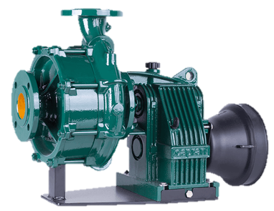

|  |  |
| --- | --- |
| **Potencia nominal del tractor** | |
| kW | 54 ÷ 57 |
| HP | 74 ÷ 78 |